NYSSLS Daily Lesson Plan
Instructional Unit:  Weather and Climate –  Air masses, Fronts and Weather  LESSON: Relative Humidity and Dew Point |  |  |  |  |  | Period(s) of Unit:  8 periods |  | Date:
Materials/Resources/Links:  RELATIVE HUMIDITY VISUAL - Google Search |  |  |  |  |  |  |  | Course:  Earth and Space Science
Special Notes for Lesson:

ANCHORING PHENOMINON: Why do clouds usually form at high altitudes?

Standards:
Science and Engineering Practices  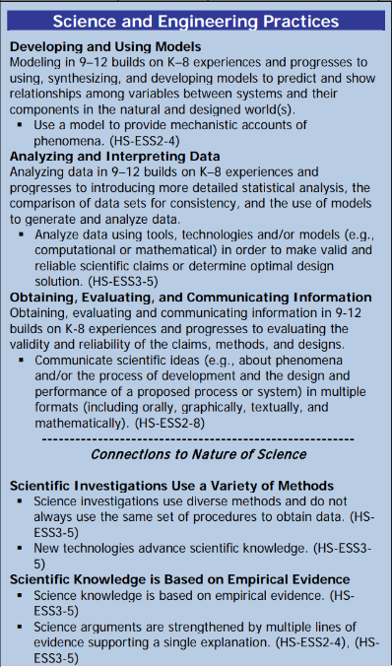 |  |  | Disciplinary Core Idea(s)  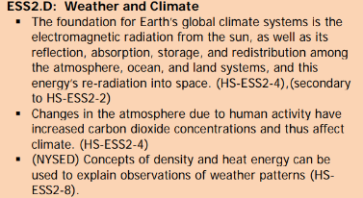 |  |  |  | Cross Cutting Concepts  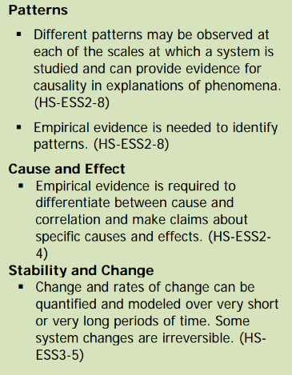
Performance Level
NYS Level 5 | NYS Level 4 |  |  | NYS Level 3 | NYS Level 2 |  |  | NYS Level 1
Collect and analyze global and regional weather data using tools, technologies, and /or models to communicate in multiple formats how the movement and interactions of airmasses result in changes in weather conditions. | Evaluate data and communicate information to explain how the movement and interactions of air masses result in changes in weather conditions |  |  | Evaluate data and communicate information to identify patterns of movement and/or the resulting changes in weather conditions. | Use data to identify the patterns of movement or the interactions of air masses and the resulting change in weather conditions  or to identify factors that drive the movement of air masses or from given weather conditions, identify evidence from maps that support these conditions. |  |  | Use data and/or patterns of movement and interactions of air masses to identify the resulting changes in weather conditions or identify one factor that drives the movement of air masses or from those provided, use evidence from maps to account for weather conditions or given weather conditions, identify evidence found on maps that account for one of these conditions.
Clarification Statement  Examples of evidence sources could include station models, surface weather maps, satellite images, radar and accepted forecast models. Emphasis should focus on communicating how the uneven heating of the Earth’s surface at frontal boundaries and resulting weather phenomena. |  |  |  |  | Assessment Boundary  Analysis is limited to surface weather maps and general weather patterns associated with High and Low pressure systems
Connection to Anchoring Phenomenon:

Relative humidity, absolute humidity and dew Point are essential concepts to understanding the workings of the atmosphere and weather.

Essential Question(s):

What does the term “relative” mean? (teacher gives examples such as I am older than you, or Charlie is taller than Sam) Students will determine the meaning of relative.

What percent of the beaker is filled with water?

Which beaker can hold more water?

How would you define relative fullness of the beaker?

If the beaker represents the air, and the water represents the water in the air (humidity), define relative humidity

How could you make the water in the beaker take up more space without adding more water to the beaker?

What happens when the beaker is completely filled with water?

If the beaker represents the atmosphere, what happens when the atmosphere is completely full with water.

Apply what you have just learned, how and why do you think clouds form?

Instructional Strategies & Learning Tasks: Engage, Explore, Explain, Elaborate, Evaluate
Engage: images, video clip or data… |  | The teacher will provide several “relative” statements such as Charlie is taller than Sam. The students will brainstorm a definition for relative..
Explore: Students investigate, experiment, hands-on activity…. |  | Students will then be given 2 different size beakers and asked to fill them half way. Students will determine the percent that the beakers are full and which beaker can hold more water.
Explain: Students share their observations and evidence to explain their understanding…possible whole group/class discussion… |  | Students will observe that both beakers are half or 50% full but one of the beakers can hold more water.
Elaborate: Students apply the science concepts they’ve just learned… |  | The teacher will tell the students that the beaker represents the air and the water represents the humidity in the air. Students will try to come up with a definition of relative humidity and absolute humitity, along with teacher guidance.  The teacher will then ask the students to devise a way to make the water take up more room in the beaker without adding more water. (Shrink the beaker)  A demonstration will show students that when air is hot it expands and when air cools it contracts.  If the beaker continued to shrink there would come a point where it would be completely full. The teacher will explain that this would be the dew point temperature of the air.  Students will then be asked to brain storm how clouds form and relate this concept to the decreasing temperature of Earth’s atmosphere with altitude.
Evaluate (Formative Assessment): Student learning is evaluated. |  | Students will be evaluated on their answers to teacher directed questions and eventually a quiz or test.

Copy and paste student worksheets below:

